**CSC 5750 – Principles of Web Technology**

**Homework 1 – Danny Haki**

**25 points – Due January 25, 5pm**

**Late deadline is January 27, 11:59pm, but 20% off**

**a)** Save this document with your name and the homework number somewhere in the file name.

**b)** Type/paste your answers into the document.

**c)** Gather the following files into a ZIP file:

● This document

● Main page (.HTML)

● Products and Services page (.HTML)

● Customer Rewards Enrollment page (.HTML)

● CSS file (.CSS)

● Image files

● Any other optional files specific to your implementation

**d)** Submit the ZIP file to the Blackboard item where you downloaded this document.

You've opened a storefront business to sell products and/or services. Create a web site for the business that has the following three web pages:

● A **Main page** that contains general information about the business including:

✓ Its purpose.

✓ A featured product or service including a description and image.

✓ Store hours.

✓ Store location shown on a map image (assume on location).

● A **Products and Services page** that shows in tabular format at least five products and/or services for sale. Include a description and image for each product and/or service.

● A **Customer Rewards Enrollment page** that provides a user a form that enables them to enroll in your customer rewards program. The form includes:

✓ Title

✓ First name

✓ Last name

✓ Preferred coupon delivery format (e-mail or snail mail)

✓ E-mail address

✓ Snail mail address

Define the form to use method **get** and action **http://www.tipjar.com/cgi-bin/test**.

Invent the business with its own unique information. It could reflect a hobby or interest you have. When creating the HTML pages, begin with the HTML templates (main and other) provided on Blackboard. Place a header with page title(s) at the top of each page. Place a footer with contact information at the bottom of each page including:

● Snail mail address.

● E-mail address as a hyperlink.

● Phone number.

● A copyright notice with current year.

Incorporate the following elements on each HTML page:

● Comments (header and body).

● Tags around all textual content (<label>, <p>, or other tag) if no other tag used.

● At least two of the six pre-defined heading styles.

● Quick styling tags <b>, <i>, and <u>.

● Links to the other two pages in a menu.

● Within the Products and Services page, links to the top and bottom of the page.

● Horizontal ruler(s).

● Within the Products and Services page, content formatted with <table>s or <div>s.

● Within the Customer Rewards Enrollment page, use of a combo box and radio buttons.

Place all styling attributes in a separate CSS file and connect it to the three HTML pages. When creating the CSS page, begin with the CSS template provided on Blackboard. Include the following properties in the CSS file:

● Font properties

● Text properties

● Color properties

● Background properties

● At least three .class styles.

● At least one :hover style.

**Main page**

*[your main page HTML code here]\**

<!DOCTYPE html>  
<html lang="en">  
 <head>  
 <link rel="stylesheet" type="text/css" href="stylesheet.css">  
 <link href="https://fonts.googleapis.com/css?family=Orbitron" rel="stylesheet">  
 </head>  
 <body>  
 <div id="blackBox">  
 <ul id="nav">  
 <li><a href="Home.html"><h2 style="font-size: 10px; font-family: Orbitron">Home</h2></a></li>  
 <li><a href="Services.html"><h2 style="font-size: 10px; font-family: Orbitron">Services</h2></a></li>  
 <li><a href="Rewards.html"><h2 style="font-size: 10px; font-family: Orbitron">Rewards</h2></a></li>  
 </ul>  
 </div>  
 <fieldset >  
 <legend><h2 style="font-size: 15px;padding-left: 10%; color: #ff3a29; font-family: Orbitron">Welcome &nbsp;</h2></legend>  
 <p style="font-size:15px;color: #bcbcbc; font-family:Orbitron">The purpose of this website is to provide I.T services to all who require them.  
 Here you will find information on what specific services are available and the costs included.  
 </p>  
 <br><br>  
 </fieldset>  
 <br><br>  
 <div id="content">  
  
 <h2 style="text-align: center; color: #ff3a29; font-family: Orbitron">Featured Service</h2>  
 <br>  
 <div class="container">  
 <div class="item">  
 <p>  
 Our Featured Service is the IT support home visit. If you or a loved one need  
 technical assistance at home, give us a call!  
 </p>  
 </div>  
 <div class="item">  
 <img src="Images/IThelp.jpg" style=";height: 200px; width: 350px;">  
 </div>  
 </div>  
 <br><br>  
 <h2 style="text-align: center; color: #ff3a29;margin-top: 30px; font-family: Orbitron">Store Hours</h2>  
 <div class="container">  
 <div class="item">  
 <p>  
 Please keep in mind that our store hours change based on holidays and speciel events!  
 </p>  
 </div>  
 <div class="item">  
 <p> M: 10 AM - 6 PM</p>  
 <p> T: 9 AM - 5 PM</p>  
 <p> W: 10 AM - 6 PM</p>  
 <p> TH: 9 AM - 5 PM </p>  
 <p> F: 10 AM - 6 PM</p>  
 <p> Sat/Sun: 9 AM - 12 PM</p>  
 </div>  
 </div>  
 <h2 style="text-align: center; color: #ff3a29;margin-top: 30px;margin-bottom: 30px; font-family: Orbitron">Location</h2>  
 <div class="container">  
 <div class="item">  
 <p>  
 Store Location: 18411 Inkster Rd Livonia 48152  
 </p>  
 </div>  
 <div class="item"> <img src="Images/StoreLocation.png"style="height: 300px;width:500px;"></div>  
 </div>  
 </div>  
 <br><br>  
 </body>  
 <br><br>  
 <footer>  
 <br><br>  
 <address style="font-family: Orbitron; color: #bcbcbc;">  
 Written by <a href="mailto:webmaster@example.com" style="color: #ff3a29">Danny Haki</a><br>  
 Visit us at: <span style="color: #ff3a29">12345 Elm Street</span><br>  
 Phone: <span style="color: #ff3a29">555-555-5555</span><br>  
 Itsupportnotreal.com<br>  
 Box 555, Imaginaryland<br>  
 USA, 2018 &#9400;  
 </address>  
 </footer>  
</html>

*[your main page screenshots here]\*\**

*Full screen:*

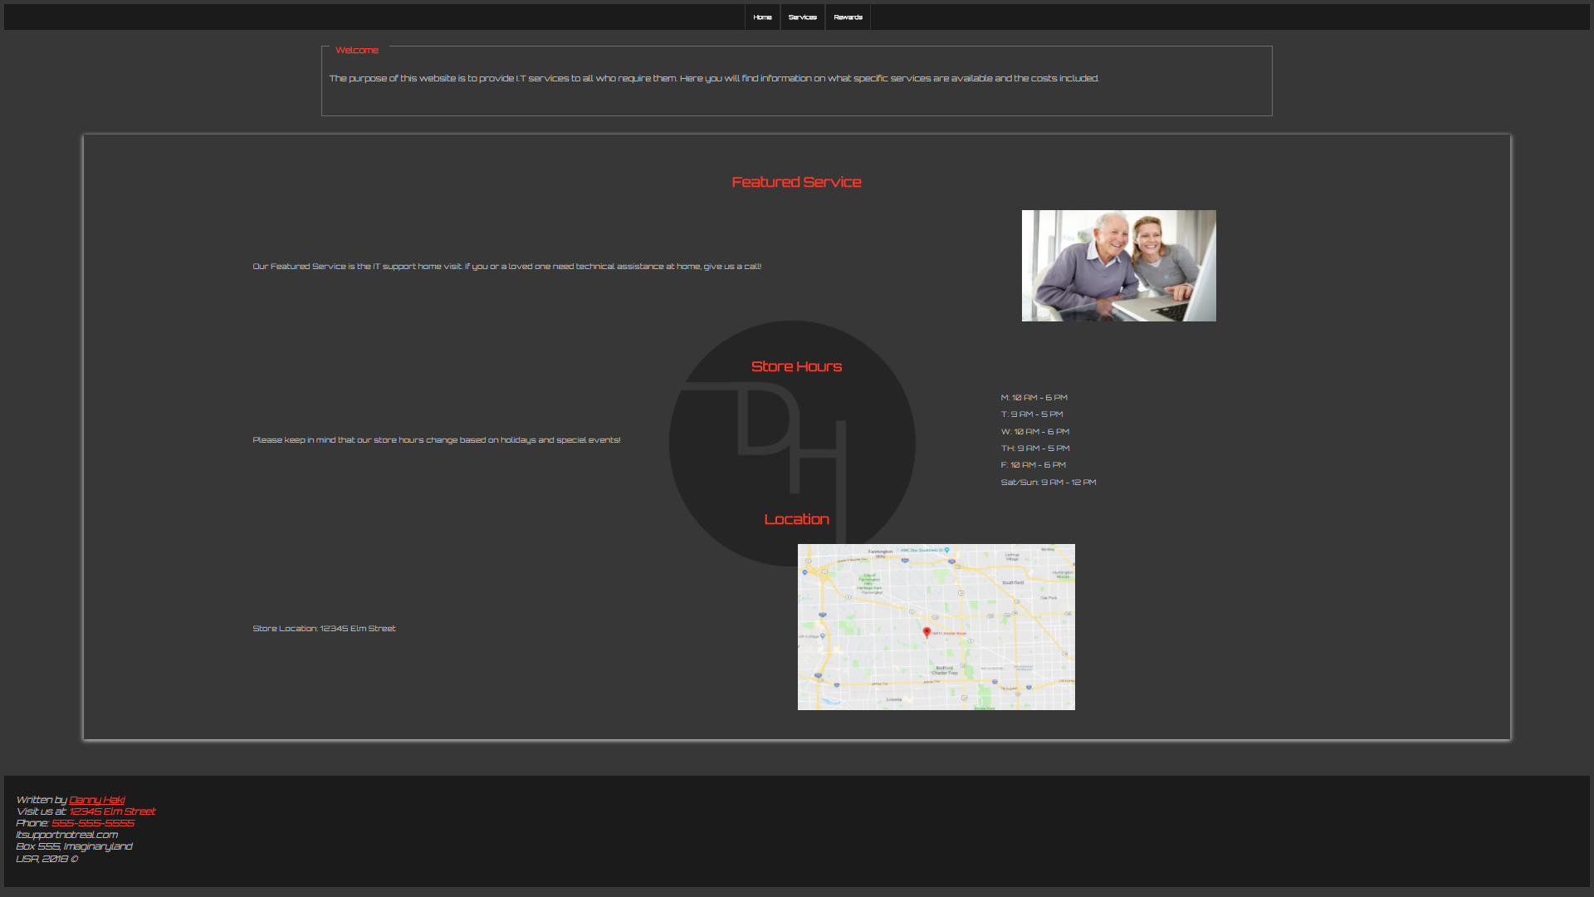

*Split up:*

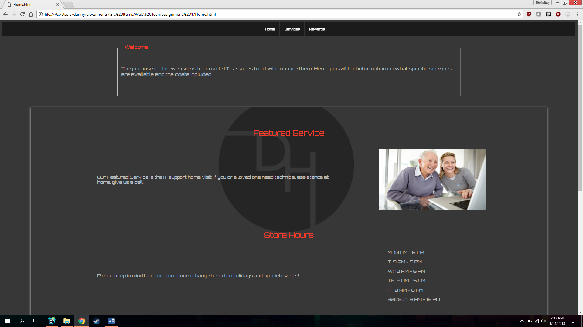

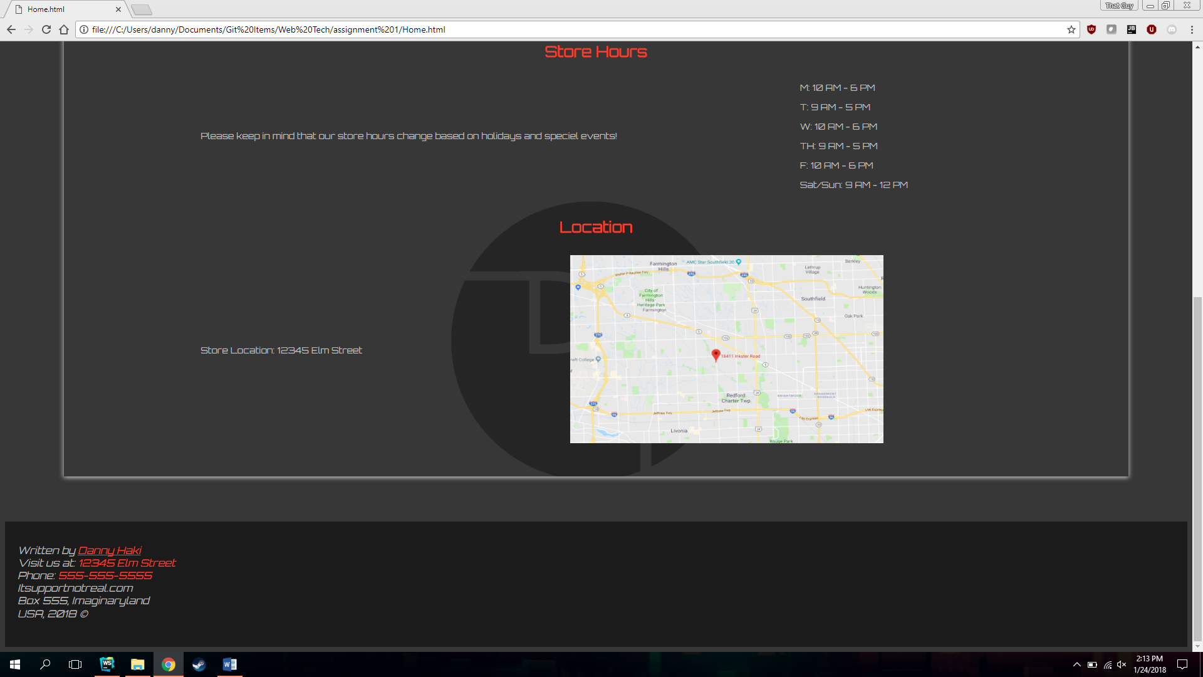

**Products and Services page**

*[your products and services page HTML code here]\**

<!DOCTYPE html>  
<html lang="en">  
<head>  
 <link rel="stylesheet" type="text/css" href="stylesheet.css">  
 <link href="https://fonts.googleapis.com/css?family=Orbitron" rel="stylesheet">  
</head>  
<body>  
 <div id="blackBox">  
 <ul id="nav">  
 <li><a href="Home.html"><h2 style="font-size: 10px; font-family: Orbitron">Home</h2></a></li>  
 <li><a href="Services.html"><h2 style="font-size: 10px; font-family: Orbitron">Services</h2></a></li>  
 <li><a href="Rewards.html"><h2 style="font-size: 10px; font-family: Orbitron">Rewards</h2></a></li>  
 </ul>  
 </div>  
 <h1 style="font-family: Orbitron; color: #ff3a29; text-align: center;font-size: 30px">Services & Prices</h1>  
 <table align="center" id="customers">  
 <tr>  
 <th>Service</th>  
 <th>Staff</th>  
 <th>Cost</th>  
 </tr>  
 <tr>  
 <td>Home Installation</td>  
 <td>Danny H</td>  
 <td>$30 + $20(h)</td>  
 </tr>  
 <tr>  
 <td>Home Support</td>  
 <td>Danny H</td>  
 <td>$30 + $30(h)</td>  
 </tr>  
 <tr>  
 <td>PC Hardware Repair</td>  
 <td>Danny H</td>  
 <td>$75</td>  
 </tr>  
 <tr>  
 <td>PC Software Cleanup</td>  
 <td>Danny H</td>  
 <td>$50 - $75</td>  
 </tr>  
 </table>  
 <br><br>  
 <div id="content">  
 <h2 style="text-align: center; color: #ff3a29;margin-top: 30px; font-family: Orbitron">Services Description</h2>  
 <div class="container">  
 <div class="item">  
 <p style="font-family: Orbitron; font-size: 14px"><span style="color: #ff3a29">Home Installation: </span> Purchased something and aren't sure on how  
 to set it up? let our trained IT personel take care of it for you! $30 for visit and $10 for every hour after that.</p>  
 </div>  
 <div class="item">  
 <img src="Images/HomeInstall.jpg" style=";height: 250px; width: 350px;">  
 </div>  
 </div>  
 <br><br>  
 <div class="container">  
 <div class="item">  
 <p style="font-family: Orbitron; font-size: 14px"><span style="color: #ff3a29">Home Support: </span> Need help understanding how to use Facebook/Twitter/Instagram?  
 Wish you had someone to sit down with you and answer all the tech related questions you have? Give us a call and have one of our trained specialists show you the ropes!  
 $30 for visit and $10 for every hour after that.  
 </p>  
 </div>  
 <div class="item">  
 <img src="Images/HomeSupport.jpg" style=";height: 250px; width: 350px;">  
 </div>  
 </div>  
 <br><br>  
 <div class="container">  
 <div class="item">  
 <p style="font-family: Orbitron; font-size: 14px"><span style="color: #ff3a29">PC Hardware Repair: </span> Computer stopped working? cant figure out what that weird sound is? Bring in your PC to our office and we will fix it for you!  
 Flat $75 for repair (does not include part costs, shipping and order.)</p>  
 </div>  
 <div class="item">  
 <img src="Images/pcrepair.jpg" style=";height: 250px; width: 350px;">  
 </div>  
 </div>  
 <br><br>  
 <div class="container">  
 <div class="item">  
 <p style="font-family: Orbitron; font-size: 14px"><span style="color: #ff3a29">PC Software Cleanup: </span> Has your computer slowed down? do pop ups constantly come up without you doing anything? if you think your system has been  
 infected by malware or a virus, bring it in for us to clean it up. $50 for a cleanup. If system cannot be recovered, we backup your data and reset the system for $75.</p>  
 </div>  
 <div class="item">  
 <img src="Images/Virus.jpg" style=";height: 250px; width: 350px;">  
 </div>  
 </div>  
 </div>  
</body>  
<br><br>  
<br><br>  
<footer>  
 <br><br>  
 <address style="font-family: Orbitron; color: #bcbcbc;">  
 Written by <a href="mailto:webmaster@example.com" style="color: #ff3a29">Danny Haki</a><br>  
 Visit us at: <span style="color: #ff3a29">12345 Elm Street</span><br>  
 Phone: <span style="color: #ff3a29">555-555-5555</span><br>  
 Itsupportnotreal.com<br>  
 Box 555, Imaginaryland<br>  
 USA, 2018 &#9400;  
 </address>  
</footer>  
</html>

*[your products and services page screenshots here]\*\**

*Fullscreen:*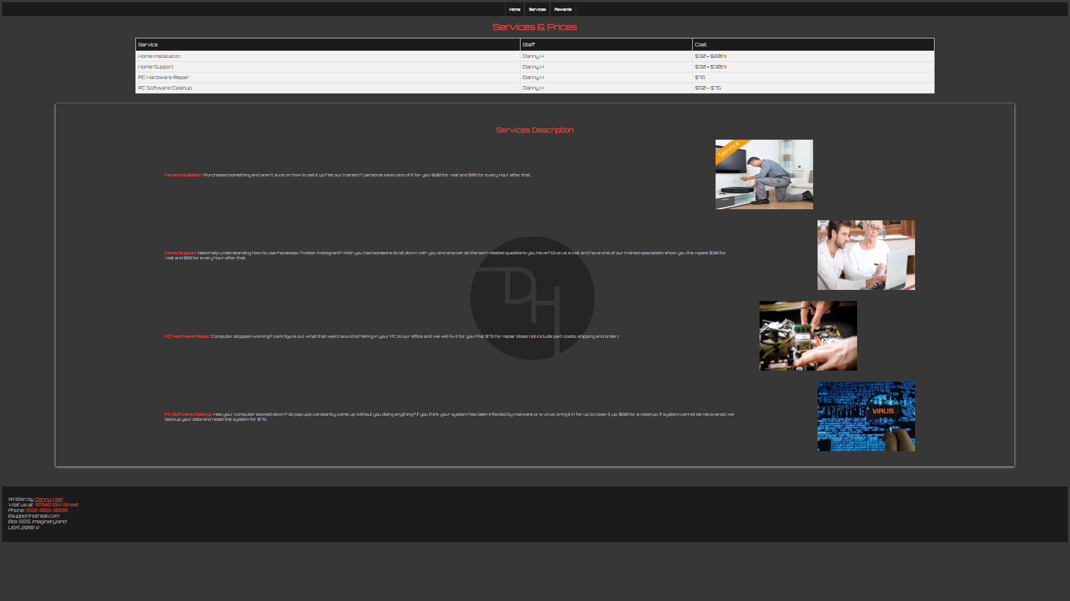

*Split up:*

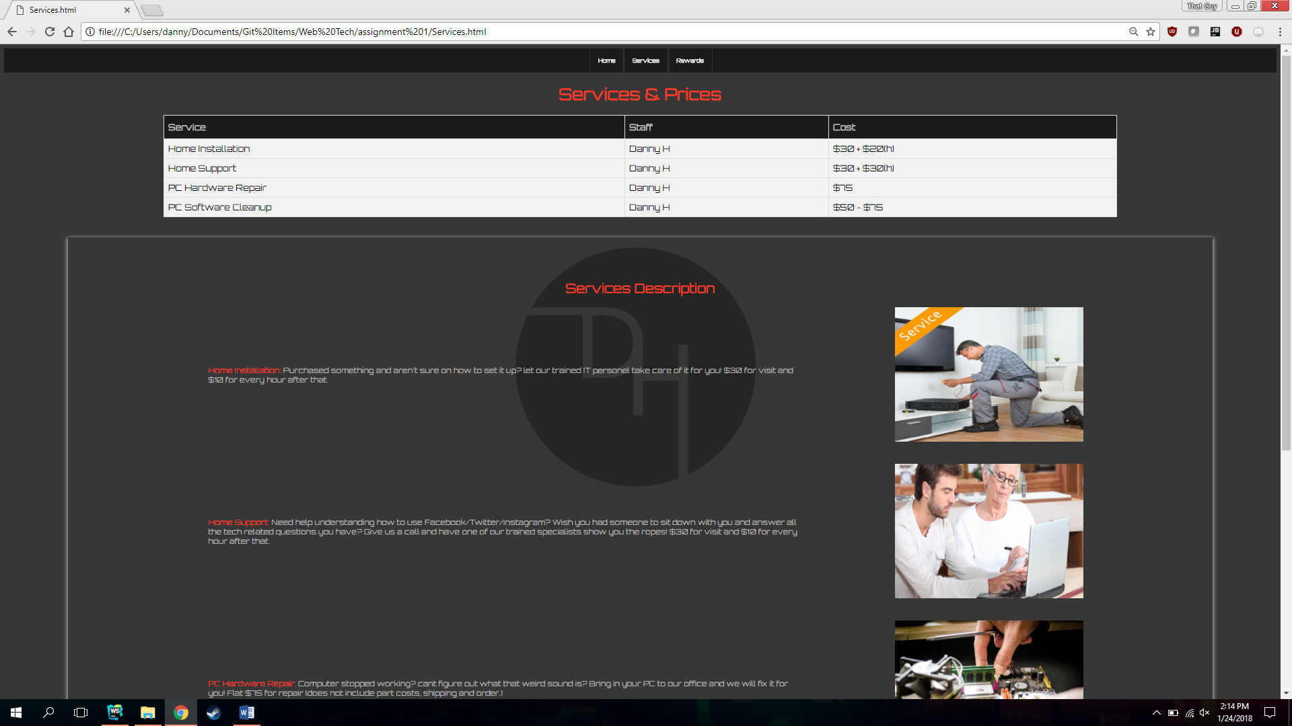

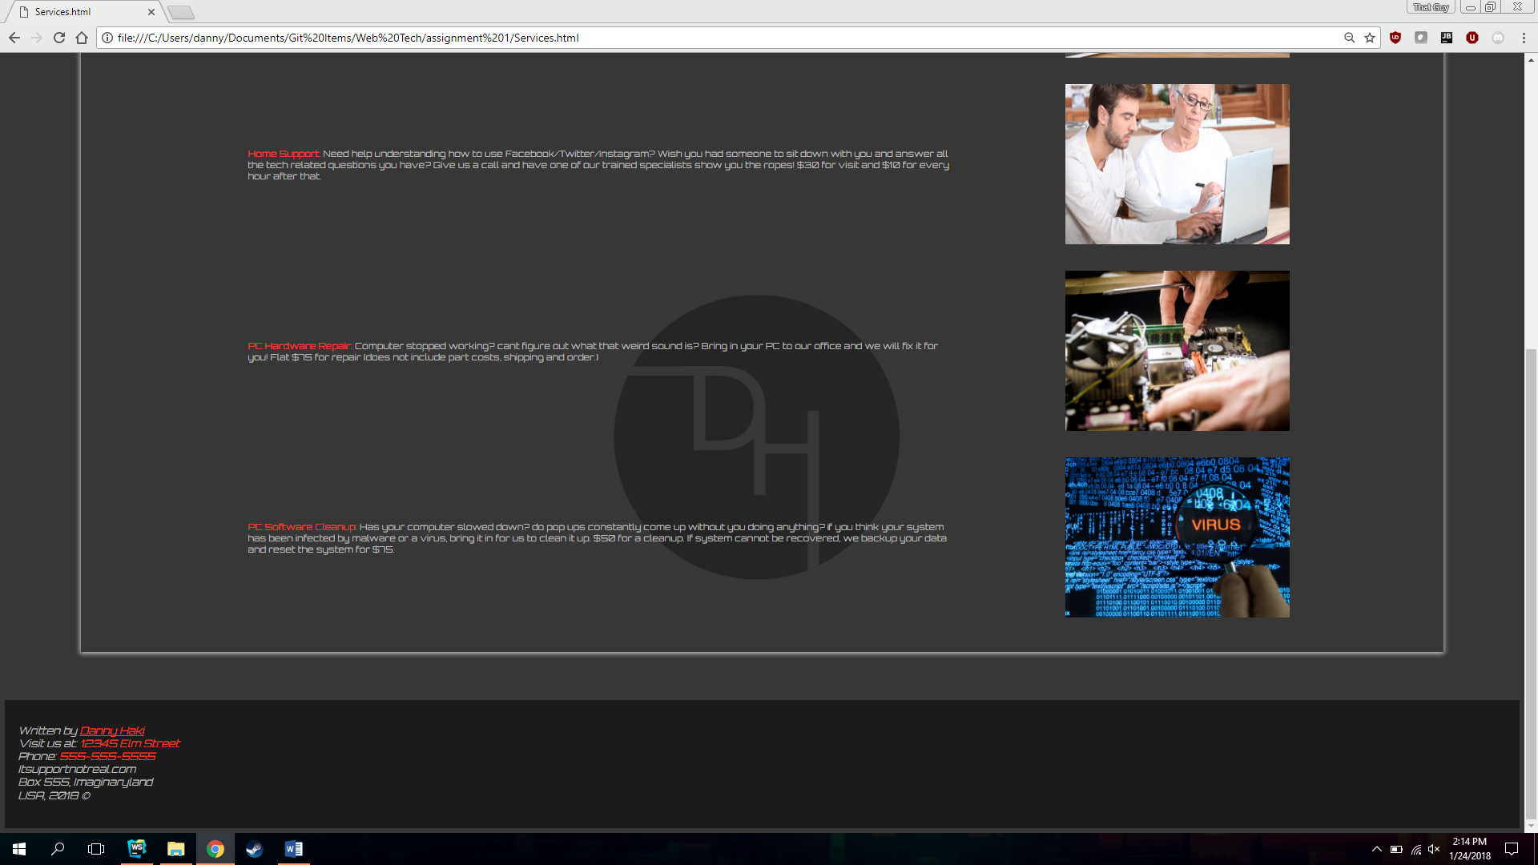

**Customer Rewards Enrollment page**

*[your Customer Rewards Enrollment page HTML code here]\**

<!DOCTYPE html>  
<html lang="en">  
 <head>  
 <link rel="stylesheet" type="text/css" href="stylesheet.css">  
 <link href="https://fonts.googleapis.com/css?family=Orbitron" rel="stylesheet">  
 </head>  
 <body>  
 <div id="blackBox">  
 <ul id="nav">  
 <li><a href="Home.html"><h2 style="font-size: 10px; font-family: Orbitron">Home</h2></a></li>  
 <li><a href="Services.html"><h2 style="font-size: 10px; font-family: Orbitron">Services</h2></a></li>  
 <li><a href="Rewards.html"><h2 style="font-size: 10px; font-family: Orbitron">Rewards</h2></a></li>  
 </ul>  
 </div>  
 <br><br>  
 <div id="content">  
 <h1 style="font-family: Orbitron; color: #ff3a29; text-align: center;font-size: 30px">Sign Up To Stay Up-To-Date!</h1>  
 <form method="get" enctype="application/x-www-form-urlencoded" action="http://www.tipjar.com/cgi-bin/test" style="font-family: Orbitron">  
 <label>Title: </label>  
 <select>  
 <option selected>----</option>  
 <option>Mr. </option>  
 <option>Mrs.</option>  
 <option>Miss </option>  
 </select>  
 <br><br>  
 <label >First name: </label>  
 <input type="text" name="txtFirstName">  
 <br><br>  
 <label >Last name: </label>  
 <input type="text" name="txtLastName">  
 <br><br>  
 <label >Please Select Mail type: </label>  
 <br>  
 <input type="radio" name="mailChoice"> Email  
 <br>  
 <input type="radio" name="mailChoice"> Snail Mail  
 <br><br>  
 <label>Please Enter your Email: </label>  
 <br>  
 <input name="Email" type="email">  
 <br><br>  
 <label>Please Enter Your Home address: </label>  
 <br>  
 <input name="Address" type="text">  
 <br><br>  
 <input type="submit" style="font-family: Orbitron" value="Submit">  
 <input type="reset" style="font-family: Orbitron" value="Reset">  
 </form>  
 </div>  
 </body>  
 <br><br>  
 <br><br>  
 <br><br>  
 <br><br>  
  
 <footer>  
 <br><br>  
 <address style="font-family: Orbitron; color: #bcbcbc;">  
 Written by <a href="mailto:webmaster@example.com" style="color: #ff3a29">Danny Haki</a><br>  
 Visit us at: <span style="color: #ff3a29">12345 Elm Street</span><br>  
 Phone: <span style="color: #ff3a29">555-555-5555</span><br>  
 Itsupportnotreal.com<br>  
 Box 555, Imaginaryland<br>  
 USA, 2018 &#9400;  
 </address>  
 </footer>  
</html>

*[your Customer Rewards Enrollment page screenshots here]\*\**

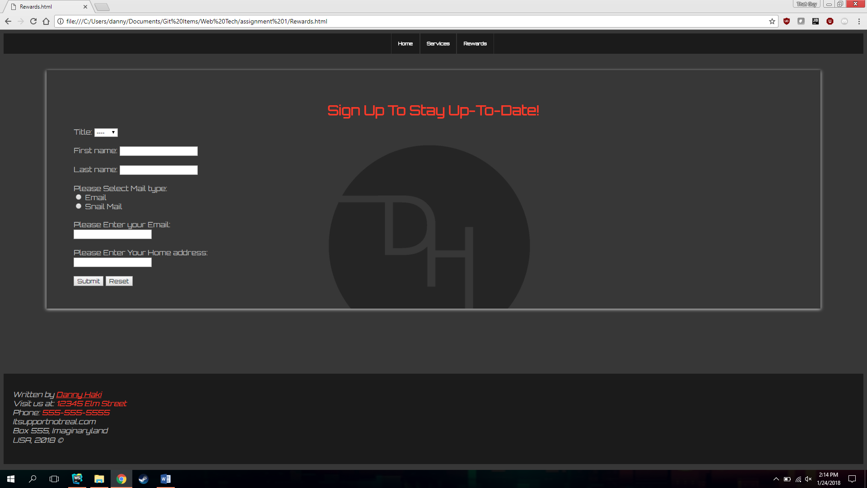

*[your www.tipjar.com/cgi-bin/test response screenshot here]\*\**

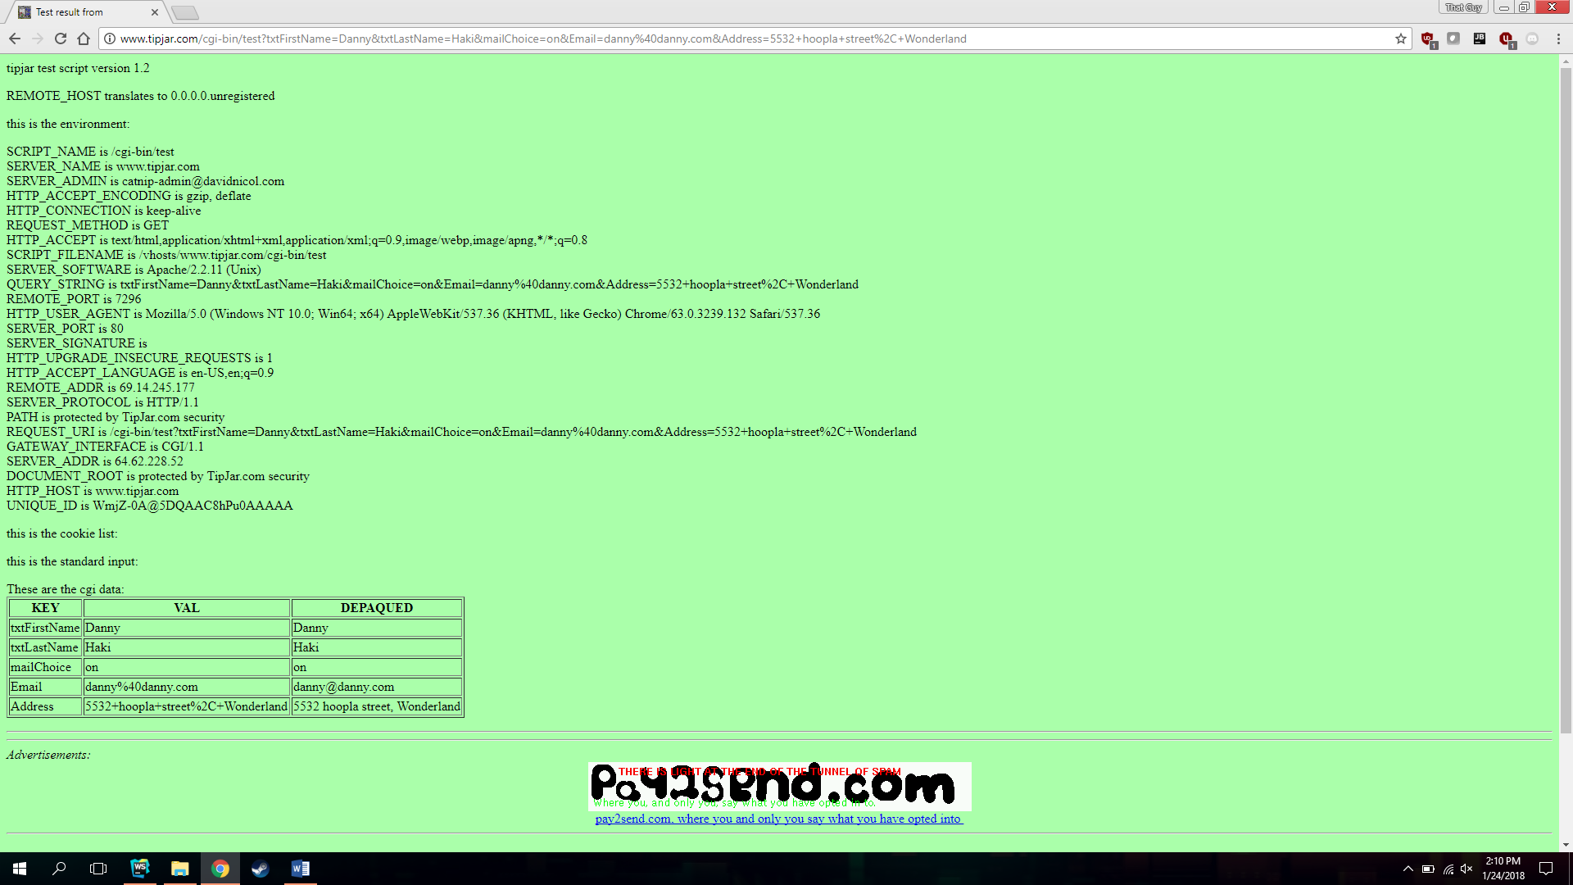

*CSS code:*

/*--------------------------------------------------------------------------------------------------  
NAVIGATION BAR  
--------------------------------------------------------------------------------------------------*/  
#blackBox {  
 background-color: #1b1b1b;  
 width:100%;  
 display: flex;  
 justify-content: center;  
}  
#nav {  
 background-color: #1b1b1b;  
 margin: 0;  
}  
#nav ul {  
 list-style: none;  
 width: 100%;  
}  
#nav li {  
 float: left;  
 display:inline;  
}  
#nav li a {  
 display: block;  
 color: white;  
 text-decoration: none;  
 padding: 8px 15px;  
 border-right: .5pt solid #333333;  
 border-left: .5pt solid #333333;  
 transition: all .3s;  
}  
#nav li a:hover {  
 margin:10px;  
 background-color: #ff3a29;  
 box-shadow: 2px 2px 10px rgba(255,255,255,.17),-2px 2px 10px rgba(255,255,255,.17);  
}  
/*--------------------------------------------------------------------------------------------------  
HEADER  
--------------------------------------------------------------------------------------------------*/  
header {  
 position: absolute;  
 width: 100%;  
  
}  
/*--------------------------------------------------------------------------------------------------  
BODY  
--------------------------------------------------------------------------------------------------*/  
body {  
 padding: 0;  
 background-size: cover;  
 background-color: #373737;  
}  
#content {  
 color: #bcbcbc;  
 display: block;  
 background-image: url("Images/Logotransback.png");  
 background-repeat: no-repeat;  
 background-position: center;  
 background-attachment: fixed;  
 background-color: #373737;  
 margin: 0 5%;  
 box-shadow: 2px 2px 10px rgba(255, 255, 255, 0.4),-2px 2px 10px rgba(255, 255, 255, 0.44);  
 padding: 50px 60px;  
 background-size: 500px;  
}  
.container{  
 display: flex;  
 padding-left: 10%;  
 flex-direction: row;  
 align-items: center;  
}  
.item{  
 order: 1;  
 flex-grow: 1;  
 padding-right: 10%;  
 font-family: Orbitron;  
 font-size: 14px  
}  
/*-----------------------------------------------------------------------------------------------  
EXTRAS  
--------------------------------------------------------------------------------------------------*/  
.shadow {  
 box-shadow: 5px 5px 30px rgba(256,256,256,.2),-5px 5px 30px rgba(256,256,256,.2);  
}  
form {  
 color: #bcbcbc;  
}  
fieldset legend {  
 padding-right: 10px;  
 padding-top: 15px;  
}  
fieldset {  
 display: block;  
 margin-left: 20%;  
 margin-right:20%;  
}  
/*--------------------------------------------------------------------------------------------------  
TABLE  
--------------------------------------------------------------------------------------------------*/  
#customers {  
 font-family: Orbitron;  
 border-collapse: collapse;  
 width: 75%;  
}  
#customers td, #customers th {  
 border: 1px solid #ddd;  
 padding: 8px;  
}  
#customers tr{  
 background-color: #f2f2f2;  
}  
#customers tr:hover {  
 background-color: #ff3a29;  
}  
#customers th {  
 padding-top: 12px;  
 padding-bottom: 12px;  
 text-align: left;  
 background-color: #1b1b1b;  
 color: #bcbcbc;  
}  
/*--------------------------------------------------------------------------------------------------  
FOOTER  
--------------------------------------------------------------------------------------------------*/  
footer{  
 background-color: #1b1b1b;  
 width:100%;  
 height: 200px;  
 bottom:0  
}  
address{  
 margin-left: 20px;  
}

* **Copying-and-pasting web page code to a Word document**

1) From the HTML editor window, press **CTRL-A** and press **CTRL-C**.

2) From within the Word document, press **CTRL-V**.

** **Copying-and-pasting application output to a Word document**

1) From the web page, maximize the browser window.

2) From the browser window, press **ALT-PrintScreen**.

3) From within the Word document, press **CTRL-V**.